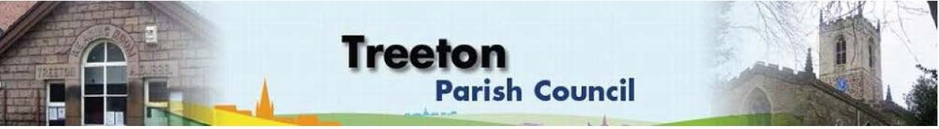
Interim Clerk to the Council – Cllr Rachel Rowbottom, The Reading Room,
25 Front Street, Treeton Rotherham. S60 5QP Telephone 07868 813 547
Email: treetonpc@aol.com
Website: www.treetonparishcouncil.gov.uk

17th January 2025

To: The Chairman and Members of the Treeton Parish Council.

Dear Parish Councillors,
You are requested to attend the next meeting of the Parish Council at 6.30pm on Monday 27th January 2025 and to be held in the Reading Room, Front Street, Treeton.
Below the agenda for the meeting.

A list of accounts for payment will be emailed with the Clerks report and updated verbally at the Parish Council meeting as necessary.

Yours sincerely
- Rowbottom.
Interim Clerk to the Council.

MEETING OF TREETON PARISH COUNCIL 27th JANUARY 2025

AGENDA

- Apologies and to resolve to accept any reasons for absence.
- Public Question Time (Maximum 15 minutes.).
- Declaration of Interest (Councillors must declare any interest they have in agenda items)
- Approve minutes of the meeting held on 25th November (attached)
- Matters arising not elsewhere on the agenda.
- Clerk’s report & correspondence
- Borough Councillor’s Report
- Project to remedy Cowfield drainage
- Planning & Review of progress on projects through 2024 (attached)
- Grant Application Requests
- HR Committee Update
- Events Working Group: Report from the Group on recent events and future plans including consideration of risk assessments, agreement to any financial implications & Parish Council sign off - Cllr Baum-Dixon/All
- Carol Singing
- Santas Grotto
- Events for 2025
- Standing items:
- Reading Room
- Parish Cllr, Housing & PCSO Surgeries – representation.
- Fire Alarm – update on stand alone alarm & decommissioning of existing.
- Allotments - update - Clerk.
- Burial Ground
- Registering the land – update
- Rules & Fees
- Recreation Ground & Play Areas – Cowfield
- Environment
- Brinsworth to High Marnham Sub Station
- Whitestone Solar Farm
- Fence at Catcliffe Flash Layby
- Footpath from Well Lane to Treeton
- Planning Applications – to receive and comment
- Newsletter – update - Cllr Baum-Dixon
- Neighbourhood Watch - update – Cllr Rowbottom
- Report from Representatives on external bodies:
  - RMBC/Parish Council’s Network Meeting - Cllr Adair
  - YLCA Branch Representatives - Cllr Parker-Foers
  - On Path (Banks Group) – Penny Hill Wind Farm – Cllr Adair
  - Treeton Youth Club – Cllr Adair
  - Community Centre – Cllr Adair
  - Community Centre & Playing Fields Memorial Cttee - Cllrs Adair/Baum-Dixon
- Finance & General Purposes.
- Financial Monitoring Report
- Approval of accounts for payment
- Budget & Precepting 2025/26: Indicative precept, fees and charges, of staffing resources and project plans as part of budget process.
- Items for information/Future Agenda
- Date of next meeting – 24th February 2025

EXCLUSION OF THE PUBLIC
To consider exclusion of the Press & Public on the grounds that the consideration of the following items may involve the likely disclosure of confidential information (s1 (2) Public Bodies (Admission of Meetings) Act 1960).

- Property – Expired Lease
- Land Issue
- Newsletter

C:\Work\Julie\Minutes & agenda\2025\January 27th 2025\Request to attend & agenda Mtg of PC 25th Jan 2025docx

