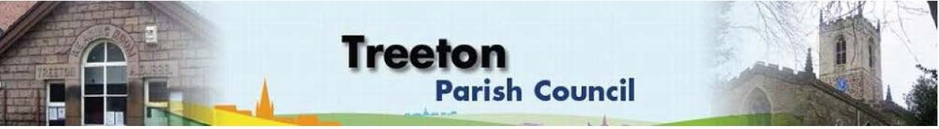

**Clerk to the Council – Mrs J James, The Reading Room, 25 Front Street, Treeton Rotherham. S60 5QP Telephone 07868 813 547 Email:** [**treetonpc@aol.com**](mailto:treetonpc@aol.com)

**Website:** [**www.treetonparishcouncil.gov.uk**](http://www.treetonparishcouncil.gov.uk/)

1st May 2024

**ANNUAL PARISH MEETING**

**READING ROOM, FRONT STREET, TREETON**

**6.30pm Monday 13th May 2024**

To all electors of Treeton,

You are invited to attend the above which will take place under the chairmanship of Wendy Parker-Foers Chairperson of the Parish Council.

The Annual Parish Meeting may by law discuss all Parish affairs and pass resolutions about them.

The following matters have so far been placed on the agenda:

1. The minutes of the last Annual Parish Meeting held 22nd May 2023

2. To receive the accounts for year ended 31st March 2024

3. To Receive the Chairperson's Report.

4. To consider Parish affairs and pass resolution thereon.

5. Any other eligible business.

Wendy Parker-Foers

Chairperson Treeton Parish Council

C:\Work\Julie\Minutes & agenda\2024\May 13th 2024 Ann Assembly\invitation and agenda Annual Meeting of the Parish 13th May 2024.docx