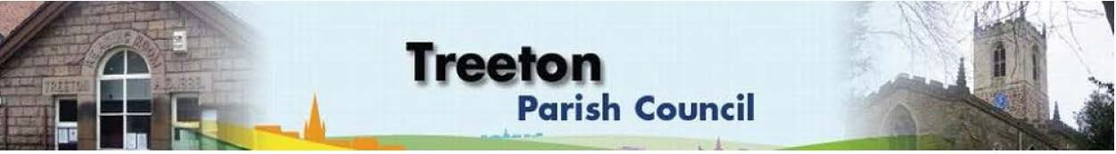
Clerk to the Council – Mrs J James, The Reading Room, 25 Front Street, Treeton Rotherham. S60 5QP Telephone 07868 813 547 Email: treetonpc@aol.com
Website: www.treetonparishcouncil.gov.uk

18th April 2024

To: The Chairperson and Members of the Treeton Parish Council.

Dear Parish Councillors,
You are requested to attend the next Parish Council meeting commencing at 6.30pm on Monday 29th April 2024 and to be held in the Reading Room, Front Street, Treeton.
Below the agenda for the meeting and attached relevant papers.

A list of accounts for payment will be emailed with the Clerks report and updated verbally at the Parish Council meeting as necessary.

Yours sincerely
- James.
Clerk to the Council.

MEETING OF TREETON PARISH COUNCIL 29th APRIL 2024

AGENDA

- Apologies and to resolve to accept any reasons for absence.
- Public Question Time (Maximum 15 minutes.).
- Declaration of Interest (Councillors must declare any interest they have in agenda items)
- Approve minutes of the meeting held on 25th March (attached)
- Matters arising not elsewhere on the agenda.
- Clerk’s report & correspondence
- Borough Councillor’s Report
- Project to remedy drainage on Cowfield – update from Cllr Adair
- Proposal for a flag pole - Cllr Beckett
- Presentation of Accounts for 2023/24:
- Report of the Internal Auditor & appointment of same for 2024/25
- Annual Governance Statement (attached)
- Accounting Statements as at 31.3.23 (attached)
- Naming the War memorial Gardens
- Land off Station Road
- Planning & Review of progress on projects through 2024 (attached)
- Events Working Group: Report from the Group on recent events and future plans including consideration of risk assessments, agreement to any financial implications & Parish Council sign off - Cllr Baum-Dixon/All
- Standing items:
- Reading Room
- Parish Cllr, Housing & PCSO Surgeries – representation.
- Allotments - update Clerk.
- Burial Ground
- Review of Management of Memorials Policy (Health & Safety) - attached
- Recreation Ground & Play Areas
- Environment
- Planning Applications – to receive and comment
- Newsletter - Review of Arrangements Cllrs Parker-Foers & Baum-Dixon
- Neighbourhood Watch - update – Cllr Rowbottom
- Report from Representatives on external bodies:
  - RMBC/Parish Council’s Liaison Committee - Cllrs Adair/Baum-Dixon
  - YLCA Branch Representatives - Cllr Parker-Foers
  - Banks Group – Penny Hill Wind Farm – Cllr Adair
  - Treeton Youth Club – Cllr Adair
  - Community Centre & Playing Fields Memorial Cttee - Cllrs Adair/Baum-Dixon
- Community Centre – Cllr Adair
- Finance & General Purposes.
- Financial Monitoring year end outturn (attached)
- Internal Control Reconciliation & Accountability (to follow)
- Review of Ear Marked Reserves (attached)
- Approval of accounts for payment (to follow)
- Items for information/Future Agenda
- Date of next meeting – Monday 13th May 2024

EXCLUSION OF THE PUBLIC
To consider exclusion of the Press & Public on the grounds that the consideration of the following items may involve the likely disclosure of confidential information (s1 (2) Public Bodies (Admission of Meetings) Act 1960).

- Property – update and decision on obtaining an interest
- Staffing matters

C:\Work\Julie\Minutes & agenda\2024\April 29th 2024\Request to attend & agenda 29th April 2024.docx

