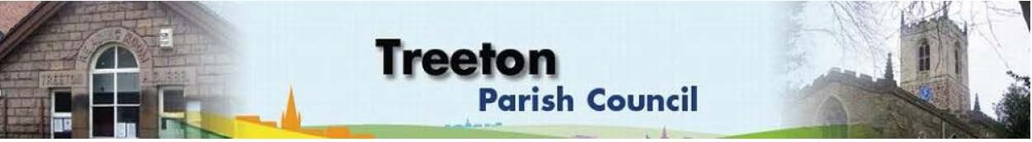
Clerk to the Council – Mrs J James, The Reading Room, 25 Front Street, Treeton Rotherham. S60 5QP Telephone 01226 745910 Email: treetonpc@aol.com
Website: www.treetonparishcouncil.gov.uk

1st December 2023

To: The Chairperson and Members of the Treeton Parish Council.

Dear Parish Councillors,
You are requested to attend the next Parish Council meeting commencing at 6.30pm on Monday 11th December 2023 and to be held in the Reading Room, Front Street, Treeton.
Below the agenda for the meeting and attached relevant papers.

A list of accounts for payment will be emailed with the Clerks report and updated verbally at the Parish Council meeting as necessary.

Yours sincerely
- James.
Clerk to the Council.

MEETING OF TREETON PARISH COUNCIL 11th DECEMBER 2023

AGENDA
- Apologies and to resolve to accept any reasons for absence.
- Public Question Time (Maximum 15 minutes.).
- Declaration of Interest (Councillors must declare any interest they have in agenda items)
- Approve minutes of the meeting held on 13th November & 4th December 2023 (attached)
- Matters arising not elsewhere on the agenda.
- Clerk’s report & correspondence
- Borough Councillor’s Report
- Wood Lane Mine Wheel – update
- Project to remedy drainage on Cowfield – update from Cllrs Adair & Scott
- Request for grant funding towards repair/equipment Washfield Lane play area - Cllr Baum-Dixon
- Planning & Review of progress on projects through 2023 (attached)
- Christmas Plans & approvals of associated Risk Assessments (attached)
      - Nativity – Cllrs Becketts & Hickey
      - Sponsored & Memorial Xmas trees – Cllrs Beckett & Hickey
      - Santa’s Grotto – Events Group
- Standing items:
- Reading Room
- Parish Cllr, Housing & PCSO Surgeries – representation.
- Refurbishment – update – Cllrs Hickey & Scott
- Letting fee to community groups
- Allotments - update Cllrs Hickey & Parker-Foers and Clerk.
- Burial Ground
- Paving – Cllr Parker-Foers
- Recreation Ground & Play Areas
- Environment
- Improvements in the Public Realm given RMBC’s programme is now reactive
- Planning Applications – to receive and comment
- Newsletter
- Update on December edition - Cllr Baum-Dixon
- Neighbourhood Watch - update – Cllr Rowbottom
- Events Working Group: Report from the Group on recent events and future plans including consideration of risk assessments, agreement to any financial implications & Parish Council sign off - Cllr Baum-Dixon/All
- Report from Representatives on external bodies:
  - RMBC/Parish Council’s Liaison Committee - Cllrs Adair/Baum-Dixon
  - YLCA Branch Representatives - Cllr Parker-Foers
  - Banks Group – Penny Hill Wind Farm – Cllr Adair
  - Treeton Youth Club – Cllr Adair
  - Community Centre & Playing Fields Memorial Cttee -Cllrs Adair/Baum-Dixon
- Community Centre – Cllr Adair
- Finance & General Purposes.
- Adoption of Biodiversity Policy (attached)
- Adoption of Working at Height Risk Assessment (attached)
- Financial Monitoring Report Month 8 (attached)
- Budget & Precepting 2024/25: To agree budget. (attached)
- Approval of accounts for payment (to follow)
- Items for information/Future Agenda
- Date of next meeting – Monday 29th January 2024

EXCLUSION OF THE PUBLIC
To consider exclusion of the Press & Public on the grounds that the consideration of the following items may involve the likely disclosure of confidential information (s1 (2) Public Bodies (Admission of Meetings) Act 1960).

- Allotments – decision re tenancy
- Property – decision on lease (attached)
- Property – decision re RMBC Warning Notice

C:\Work\Julie\Minutes & agenda\2023\Dec 11th 2023\Request to attend & agenda 11th Dec 23.docx

