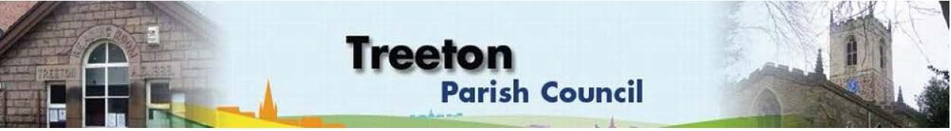
Clerk to the Council – Mrs J James, 14 Wharncliffe Close, Hoyland, BARNSLEY S74 0HP. Telephone 01226 745910 Email: treetonpc@aol.com
Website: www.treetonparishcouncil.gov.uk

20th July 2023

To: The Chairperson and Members of the Treeton Parish Council.

Dear Parish Councillors,
You are requested to attend the next Parish Council meeting commencing at 6.30pm on Monday 31st July 2023 and to be held in the Baptist Church, Station Road, Treeton.
Below the agenda for the meeting and attached relevant papers.

A list of accounts for payment will be emailed with the Clerks report and updated verbally at the Parish Council meeting as necessary.

Yours sincerely
- James.
Clerk to the Council.

MEETING OF TREETON PARISH COUNCIL 31st JULY 2023

AGENDA
- Apologies and to resolve to accept any reasons for absence.
- Private Security – a sharing of information and fact finding with input from 2 residents who have specialist knowledge. (Maximum 30 minutes to include Q&A)
- Public Question Time (Maximum 15 minutes.).
- Declaration of Interest (Councillors must declare any interest they have in agenda items)
- Approve minutes of the meeting held on 26th June 2023 (attached)
- Matters arising not elsewhere on the agenda.
- Clerk’s report & correspondence
- Borough Councillor’s Report
- Wood Lane Mine Wheel – update from Cllrs Parker-Foers & Croxton
- War Memorial Project – update from Cllr Parker-Foers
- Security in Treeton: Actions following the Community Meeting & Next Steps - All
- Partnership with RMBC to cut Public Rights of Way – Cllr Beckett
- Planning & Review of progress on projects through 2023 (attached)
- Proposals to remedy drainage on Cowfield – Cllrs Adair & Baum-Dixon
- Nativity – Cllr Beckett
- Standing items:
- Reading Room
- Parish Cllr, Housing & PCSO Surgeries – representation.
- Refurbishment/storage – update Cllr Parker-Foers
- Proposals for processes, terms, conditions and fees for letting.
- Allotments - update Clerk
- Burial Ground
- Recreation Ground & Play Areas
- Environment
- Rubbish on banks of Treeton Dyke and surrounds
- Proposed work on River Rother and impact on wildlife – Cllr Croxton
- Planning Applications – to receive and comment
- Newsletter – Cllr Baum-Dixon
- Update & decision on inclusion of PCllr emails
- Plans for September/Autumn edition
- Neighbourhood Watch – update – Cllr Rowbottom
- Report from Events Working Group & Plans for Unsung Hero Event - Cllr Baum-Dixon
- Report from Representatives on external bodies:
  - RMBC/Parish Council’s Liaison Committee - Cllr Adair/Baum-Dixon
  - YLCA Branch Representatives - Cllr Parker-Foers
  - Banks Group – Penny Hill Wind Farm – Cllr Adair
  - Treeton Youth Club – Cllr Adair
  - Community Centre & Playing Fields Memorial Cttee -Cllrs Adair/Baum-Dixon
- Community Centre – Cllr Adair
- Chairperson's Review.
- Finance & General Purposes.
- Financial Monitoring Report Month 3 (attached)
- Internal Control Reconciliation & Accountability
- Approval of accounts for payment (to follow)
- Items for information/Future Agenda
- Date of next meeting – Monday 25th September 2023

EXCLUSION OF THE PUBLIC
To consider exclusion of the Press & Public on the grounds that the consideration of the following items may involve the likely disclosure of confidential information (s1 (2) Public Bodies (Admission of Meetings) Act 1960).

- Staffing matters.

C:\Work\Julie\Minutes & agenda\2023\July 31 2023\Request to attend & agenda31st July 23.docx

