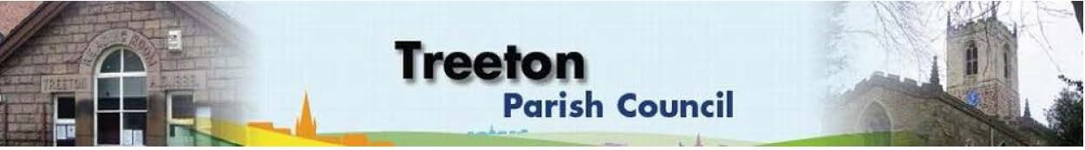
Clerk to the Council – Mrs J James, 14 Wharncliffe Close, Hoyland, BARNSLEY S74 0HP. Telephone 01226 745910 Email: treetonpc@aol.com
Website: www.treetonparishcouncil.gov.uk

15th June 2023

To: The Chairman and Members of the Treeton Parish Council.

Dear Parish Councillors,
You are requested to attend the next Parish Council meeting commencing at 6.30pm on Monday 26th June 2023 and to be held in the Baptist Church, Station Road, Treeton.
Below the agenda for the meeting and attached relevant papers.

A list of accounts for payment will be emailed with the Clerks report and updated verbally at the Parish Council meeting as necessary.

Yours sincerely
- James.
Clerk to the Council.

MEETING OF TREETON PARISH COUNCIL 26th JUNE 2023

AGENDA
- Apologies and to resolve to accept any reasons for absence.
- Public Question Time (Maximum 15 minutes.).
- Declaration of Interest (Councillors must declare any interest they have in agenda items)
- Approve minutes of the meeting held on 22nd May 2023 (attached)
- Matters arising not elsewhere on the agenda.
- Clerk’s report & correspondence
- Borough Councillor’s Report
- Wood Lane Mine Wheel – update.
- War Memorial Project – update from Cllr Parker-Foers
- Newsletter – Cllr Baum-Dixon
- Security in Treeton: CCTV – Cllrs Hickey/Baum-Dixon
- Planning & Review of progress on projects through 2023 (attached)
- Proposals to remedy drainage on Cowfield - Agreement in principle to grant application (75%) & ring fence budget (25%) of potential costs – Cllrs Adair/Baum-Dixon
- Planting tubs Bole Hill – Cllr Beckett
- Standing items:
- Reading Room
- Parish Cllr, Housing & PCSO Surgeries: frequency, content & attendance
- Refurbishment/storage – update Cllrs Adair, Baum-Dixon, Parker-Foers
- Pointing Side Stone Elevation
- Proposals for processes, conditions and fees for letting.
- Allotments - update Clerk
- Burial Ground
- Review of Burial Ground Regulations & Guidelines
- Recreation Ground and Play areas – Consider a request by Terriers to site a container on the Cowfield – Cllr Baum-Dixon
- Environment
- Planning Applications – to receive and comment
- Report from Events Working Group and Adoption of Risk Assessment for Scarecrow event - Cllr Baum-Dixon
- Report from Representatives on external bodies:
  - RMBC/Parish Council’s Liaison Committee - Cllr Adair/Baum-Dixon
  - YLCA Branch Representatives - Cllr Parker-Foers
  - Banks Group – Penny Hill Wind Farm – Cllr Adair
  - Treeton Youth Club – Cllr Adair
  - Community Centre & Playing Fields Memorial Cttee -Cllrs Adair/Baum-Dixon
- Community Centre – Cllr Adair
- Chairman's Review.
- Finance & General Purposes.
- To consider and determine any applications for grants and donations.
- Financial Monitoring Report Month 2 (attached)
- Approval of accounts for payment (to follow)
- Items for information/Future Agenda
- Date of next meeting – Monday 31st July 2023

EXCLUSION OF THE PUBLIC
To consider exclusion of the Press & Public on the grounds that the consideration of the following items may involve the likely disclosure of confidential information (s1 (2) Public Bodies (Admission of Meetings) Act 1960).

- Allotment Tenancies

C:\Work\Julie\Minutes & agenda\2023\June 26 2023\Request to attend & agenda 26th June 23.docx

