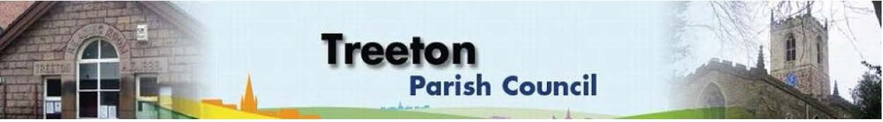
Clerk to the Council – Mrs J James, 14 Wharncliffe Close, Hoyland, BARNSLEY S74 0HP. Telephone 01226 745910 Email: treetonpc@aol.com
Website: www.treetonparishcouncil.gov.uk

13th April 2023

To: The Chairman and Members of the Treeton Parish Council.

Dear Parish Councillors,
You are requested to attend the next Parish Council Meeting at 6.30pm on Monday 24th April 2023 and to be held in the meeting room in the Baptist Church, Station Road, Treeton.
Below the agenda for the meeting and attached relevant papers.

A list of accounts for payment will be emailed with the Clerks report and updated verbally at the Parish Council meeting as necessary.

Yours sincerely
- James.
Clerk to the Council.

MEETING OF THE PARISH COUNCIL 24th APRIL 2023

AGENDA

- Apologies and to resolve to accept any reasons for absence.
- Public Question Time (Maximum 15 minutes.).
- Declaration of Interest (Councillors must declare any interest they have in agenda items)
- Approve minutes of the meeting held on 27th March 2023 (attached)
- Matters arising not elsewhere on the agenda.
- Clerk’s report & correspondence
- Borough Councillors Report
- Wood Lane Mine wheel – update on advice from RMBC Planning & on residents’ consultation
- War Memorial - Project for restoration – update from Cllr Parker-Foers
- Plans for the Newsletter – update Cllrs Baum-Dixon, Croxton, Parker-Foers
- Planning & Review of progress on projects through 2023 (attached)
- Update on proposals/grant opportunity to remedy drainage on Cowfield – Cllr Adair
- Options for planting coal tubs on Bole Hill – Cllr Beckett
- Standing items:
- Reading Room
- Parish Councillor, Housing & PCSO Surgeries
- Proposals for refurbishment/storage – update from Cllrs Adair/ Baum-Dixon/
Beckett/Parker-Foers
- Allotments – report from periodic allotment check
- Burial Ground.
- Recreation Ground and Play areas
- Environment
- Planning Applications – to receive and comment.
- Report from Events Working Group – Cllrs Baum-Dixon/Beckett/Hickey/Levin/Rowbottom
- Report from Representatives on external bodies
  - RMBC/Parish Council’s Liaison Committee - Cllrs Adair/Baum-Dixon
  - YLCA Branch Representatives - Cllr Adair
  - Banks Group – Penny Hill Wind Farm – Cllr Adair
  - Treeton Youth Club – Contract, fees & general update - Cllr Baum-Dixon
  - Community Centre & Playing Fields Memorial Cttee Cllrs Adair/Baum-Dixon
- Community Centre Update– Cllr Adair
- Chairman's Review.
- Finance & General Purposes.
- 2022/23 Outturn (attached)
- Internal Control Reconciliation & Accountability
- Decision on Management of Reserves (attached)
- Agree a budget for Events – Cllr Baum-Dixon
- Approval of accounts for payment (To follow)
- Items for information/Future Agenda
- Date of next meeting – Monday 22nd May 2023

C:\Work\Julie\Minutes & agenda\2023\April 24th\Request to attend & agenda 24th April 2023 PC meeting.docx

