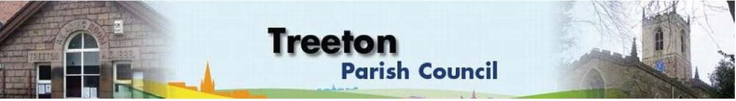
Clerk to the Council – Mrs J James, 14 Wharncliffe Close, Hoyland, BARNSLEY S74 0HP. Telephone 01226 745910 Email: treetonpc@aol.com
Website: www.treetonparishcouncil.gov.uk

12th November 2022

To: The Chairman and Members of the Treeton Parish Council.

Dear Parish Councillors,
You are requested to attend the next Parish Council Meeting at 6.30pm on Monday 21st November 2022 and to be held in the Reading Room.
Below the agenda for the meeting and attached relevant papers.

A list of accounts for payment will be emailed with the Clerks report and updated verbally at the Parish Council meeting as necessary.

Yours sincerely
- James.
Clerk to the Council.

MEETING OF THE PARISH COUNCIL 21ST NOVEMBER 2022

AGENDA

- Apologies and to resolve to accept any reasons for absence.
- Public Question Time (Maximum 15 minutes.).
- Declaration of Interest (Councillors must declare any interest they have in agenda items)
- Approve minutes of the meeting held on 24th October 2022 (attached)
- Matters arising not elsewhere on the agenda.
- Clerk’s report & correspondence
- Borough Councillors Report
- War Memorial - Project for restoration – update from Cllr Parker-Foers/Clerk
- Antisocial behaviour – Well lane/Bole hill – Cllr Scott
- Planning & Review of progress on projects through 2022 (attached)
- Update on proposals to remedy drainage on the Cowfield – Cllr Adair
- Santa’s Sleigh – Cllr Baum-Dixon
- Treeton Christmas Bake-off – Cllr Beckett
- Nativity – Cllr Beckett
- Christmas lights & tree: Update & risk assessment (attached) – Cllr Beckett
- Standing items:
- Reading Room
- Parish Councillor, Housing & PCSO Surgeries
- Proposals for refurbishment – update from Cllrs Beckett & Parker-Foers /Clerk
- Allotments – update from Clerk
- Burial Ground
- Land for Extension – update from Clerk
- Schedule of Repair & Maintenance - update from Cllr Parker-Foers/Clerk
- Recreation Ground and Play areas
- Environment
- Planning Applications – to receive and comment
- Report from Representatives on external bodies:
  - RMBC/Parish Council’s Liaison Committee - Cllrs Adair/Baum-Dixon
  - YLCA Branch Representatives - Cllr Adair
  - Banks Group – Penny Hill Wind Farm – Cllr Adair
  - Treeton Youth Club – Cllr Adair
  - Community Centre & Playing Fields Memorial Cttee Cllrs Adair/Baum-Dixon
- Community Centre Update– Cllr Adair
- Chairman's Review.
- Finance & General Purposes.
- Budget & Precepting 2023/24 & review of fees and charges, of staffing resources and project plans as part of budget planning.
- Civility & Respect Policy; Parish Councillor/Officer Protocol (attached)
- Budget Monitoring (attached)
- Approval of accounts for payment (to follow)
- Any other urgent business
- Date of next meeting – Monday 12th December 2022

EXCLUSION OF THE PUBLIC

- To consider exclusion of the Press & Public on the grounds that the consideration of the following items may involve the likely disclosure of confidential information (s1 (2) Public Bodies (Admission of Meetings) Act 1960).

- Allotment – condition and tenancy issues.

C:\Work\Julie\Minutes & agenda\Nov 21st 2022\Request to attend & agenda 21 Nov 22 PC meeting.docx

