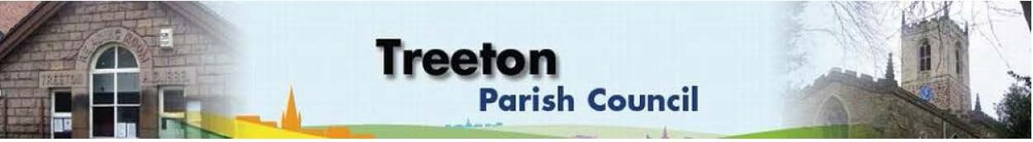
Clerk to the Council – Mrs J James, 14 Wharncliffe Close, Hoyland, BARNSLEY S74 0HP. Telephone 01226 745910 Email: treetonpc@aol.com
Website: www.treetonparishcouncil.gov.uk

13th April 2022

To: The Chairman and Members of the Treeton Parish Council.

Dear Parish Councillors,
You are requested to attend the next Parish Council Meeting commencing at 6.30pm on Monday 25th April 2022 and to be held in the Reading Room.
Below the agenda for the meeting and attached relevant papers.

A list of accounts for payment will be emailed with the Clerks report and updated verbally at the Parish Council meeting as necessary.

Hard copies of papers will be provided for the meeting.

Yours sincerely
- James.
Clerk to the Council.

MEETING OF THE PARISH COUNCIL

AGENDA

- Apologies and to resolve to accept any reasons for absence.
- Public Question Time (Maximum 15 minutes.).
- Declaration of Interest (Councillors must declare any interest they have in agenda items)
- Approve minutes of the meeting held on 28th March 2022 (attached)
- Matters arising not elsewhere on the agenda.
- Clerk’s report & correspondence (to follow)
- Borough Councillors Report
- Presentation of Accounts for 2021/22: Approval of Annual Governance & Accountability Return 2021/22 & Annual Report 2021/22
- Report of the Internal Auditor (to follow) & Appointment of same for 2022/23
- Annual Governance Statement (attached)
- Accounting Statements as at 31.3.22 (attached)
- Annual Report 2021/22 (attached)
- Wood Lane – decision regarding retaining any future interest.
- Use of secure email addresses –implementation - Cllr Baum-Dixon
- Planning & Review of progress on projects through 2022 (attached)
  - Plans for sport/recreation and other facilities that might be funded by CIL/Reserves:
  - Update on approach to RMBC re Well Lane
  - Update on proposals to address drainage on Cowfield
  - Plans for HM The Queen’s Jubilee
  - Support for street parties
  - Commemorative memento
  - Beating the Bounds – Cllr Beckett
  - Baking Competition – Cllrs Levin & Beckett
  - Commemorative tree by Wood Lane mine wheel – Cllr Pickford
  - Commemorative tree planting – Cllr Pickford
- Standing items
- Reading Room
  - Parish Councillor & Housing Surgeries
  - Opening for letting – decision on whether to open for bookings
- Allotments/Garages
- Burial Ground:
  - Land for an extension
- Recreation Ground and Play areas
- Environment
  - Suggestions for signage to & in the village – Cllr Pickford
- Planning Applications
- Report from Representatives on external bodies
- RMBC/Parish Council’s Liaison Committee - Cllr Adair
- YLCA Branch Representatives – Cllr Adair
- Banks Groups – Penny Hill Wind Farm – Cllr Adair
- Treeton Youth Club - Cllr Adair
- Community Centre & Playing Fields Memorial Committee - Cllrs Adair/Pickford
- Community Centre - Cllr Adair
- Chairman's Review.
- Finance & General Purposes.
- Internal Control, Reconciliation & Accountability (to be tabled)
- Approval of accounts for payment (to follow)
- Any other urgent business
- Date of next meeting & of Annual Assembly – Monday 30th May 2022

C:\Work\Julie\Minutes & agenda\April 25 2022\Request to attend and Agenda 25 April 2022.docx

