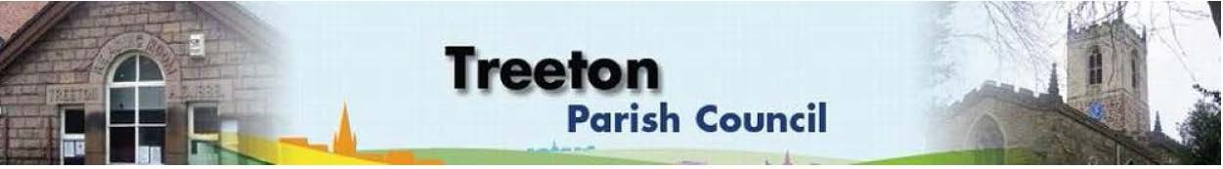

**Clerk to the Council – Mrs J James, 14 Wharncliffe Close, Hoyland, BARNSLEY S74 0HP. Telephone 01226 745910 Email:** [**treetonpc@aol.com**](mailto:treetonpc@aol.com)

**Website:** [**www.treetonparishcouncil.gov.uk**](http://www.treetonparishcouncil.gov.uk/)

3rd December 2021

To: The Chairman and Members of the Treeton Parish Council.

Dear Parish Councillors,

You are requested to attend the next Parish Council Meeting commencing at **6.30pm on Monday 13th December 2021** and to be held in the Reading Room.

Below the agenda for the meeting and attached relevant papers.

A list of accounts for payment will be emailed with the Clerks report and updated verbally at the Parish Council meeting as necessary.

Hard copies of papers will be provided for the meeting.

Yours sincerely

1. ***James****.*

Clerk to the Council.

**MEETING OF THE PARISH COUNCIL**

**AGENDA**

1. Apologies and to resolve to accept any reasons for absence.
2. Public Question Time (Maximum 15 minutes.).
3. Declaration of Interest (Councillors must declare any interest they have in agenda items)
4. Approve minutes of the meetings held on 22nd & 30th November 2021 (attached)
5. Matters arising not elsewhere on the agenda.
6. Clerk’s report & correspondence (to follow)
7. Borough Councillors Report
8. Use of secure email addresses – Decision required - Cllr Baum-Dixon
9. Planning & Review of progress on projects through 2021 (attached)
   1. Decision on Proposal for MUGA on Cowfield – Cllr Pickford
10. Standing items
11. Reading Room
    1. Parish Councillor & Housing Surgeries incl Sat 18th Dec drop in
12. Allotments/Garages:
13. Recommendations from allotment check
14. Burial Ground:
    1. Land for an extension: decision required to secure legal services & arrangements for secure storage of deeds and leases - Clerk
15. Recreation Ground and Play areas
16. Environment
17. Old burial ground: decision to paint gates – Cllr Parker-Foers
18. Planning Applications
19. Report from Representatives on external bodies
20. RMBC/Parish Council’s Liaison Committee - Cllr Adair
21. YLCA Branch Representatives – Cllr Adair
22. Treeton Youth Club - Cllr Adair
23. Community Centre & Playing Fields Memorial Committee - Cllrs Adair/Pickford
24. Community Centre - Cllr Adair
25. Chairman's Review.
26. Finance & General Purposes.
27. Pensions Re-enrollment
28. Budget Monitoring (attached)
29. Precepting 2022/23: Draft 2022/23 budget & to agree precept (attached)
30. Approval of accounts for payment (to follow)
31. Any other urgent business
32. Date of next meeting – Monday 24th January 2022

EXCLUSION OF THE PUBLIC

To consider exclusion of the Press & Public on the grounds that the consideration of the following items may involve the likely disclosure of confidential information (s1 (2) Public Bodies (Admission of Meetings) Act 1960).

1. Update on actions in respect of Staffing Resources to deliver Parish Priorities
2. Update on property matters

C:\Work\Julie\Minutes & agenda\Dec 13 2021\Request to attend and Agenda 13 Dec 21.docx