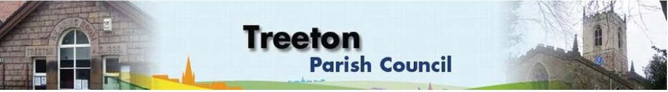

**Clerk to the Council – Mrs J James, 14 Wharncliffe Close, Hoyland, BARNSLEY S74 0HP. Telephone 01226 745910 Email:** [**treetonpc@aol.com**](mailto:treetonpc@aol.com)

**Website:** [**www.treetonparishcouncil.gov.uk**](http://www.treetonparishcouncil.gov.uk/)

10th November 2021

To: The Chairman and Members of the Treeton Parish Council.

Dear Parish Councillors,

You are requested to attend the next Parish Council Meeting commencing at **6.30pm on Monday 22nd November 2021** and to be held in the Reading Room.

Below the agenda for the meeting and attached relevant papers.

A list of accounts for payment will be emailed with the Clerks report and updated verbally at the Parish Council meeting as necessary.

Hard copies of papers will be provided for the meeting.

Yours sincerely

1. ***James****.*

Clerk to the Council.

**MEETING OF THE PARISH COUNCIL**

**AGENDA**

1. Apologies and to resolve to accept any reasons for absence.
2. Public Question Time (Maximum 15 minutes.).
3. Declaration of Interest (Councillors must declare any interest they have in agenda items)
4. Approve minutes of the meeting held on 25th October 2021 (attached)
5. Matters arising not elsewhere on the agenda.
6. RMBC Joint Working Agreement – update - Cllr Allen & RMBC Officer
7. Clerk’s report & correspondence (to follow)
8. Borough Councillors Report
9. Decision on proposals to relocate general & dog waste bin provision across Treeton - (attached) - Cllr Parker-Foers
10. Use of secure email addresses – Decision required - Cllr Dixon
11. Planning & Review of progress on projects through 2021 (attached)
    1. Decision on Christmas event at Reading Rooms
    2. Decision on Proposal for MUGA on Cowfield – Cllr Pickford
12. Standing items
13. Reading Room
    1. Parish Councillor & Housing Surgeries
    2. Lettings
    3. CCTV – Cllr Pickford
14. Allotments/Garages:
15. Allotment condition notices to improve - Clerk
16. Burial Ground:
    1. Land for an extension - Clerk
    2. Update on Grounds Maintenance contract - Clerk
    3. Decision on funding reinstating memorial laid flat during the safety inspection - Cllr Pickford
17. Recreation Ground and Play areas
18. Environment
19. Planning Applications
20. Report from Representatives on external bodies
21. RMBC/Parish Council’s Liaison Committee - Cllr Adair
22. YLCA Branch Representatives – Cllr Adair
23. Treeton Youth Club - Cllr Adair
24. Community Centre & Playing Fields Memorial Committee - Cllrs Adair/Pickford
25. Community Centre - Cllr Adair
26. Chairman's Review.
27. Finance & General Purposes.
28. Budget Monitoring & mid-year internal audit (attached)
29. Precepting 2022/23: Review of Fees & Charges, Staffing Resources and Project plans as part of budget planning for 2022/23 (to follow)
30. Approval of accounts for payment (to follow)
31. Any other urgent business
32. Date of next meeting – Monday 13th December 2021

EXCLUSION OF THE PUBLIC

To consider exclusion of the Press & Public on the grounds that the consideration of the following items may involve the likely disclosure of confidential information (s1 (2) Public Bodies (Admission of Meetings) Act 1960).

1. Update on actions in respect of Staffing Resources to deliver Parish Priorities
2. Update on property matters

C:\Work\Julie\Minutes & agenda\Nov 22 2021\Request to attend and Agenda 22 Nov 21.docx