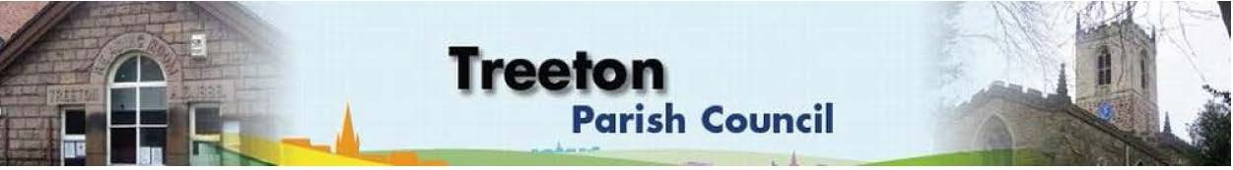

**Clerk to the Council – Mrs J James, 14 Wharncliffe Close, Hoyland, BARNSLEY S74 0HP. Telephone 01226 745910 Email:** [**treetonpc@aol.com**](mailto:treetonpc@aol.com)

**Website:** [**www.treetonparishcouncil.gov.uk**](http://www.treetonparishcouncil.gov.uk/)

24th November 2021

To: The Chairman and Members of the Treeton Parish Council.

Dear Parish Councillors

You are requested to attend an Extraordinary Meeting of the Parish Council commencing at **6.30pm on Tuesday 30th November 2021** and to be held in the Reading Room.

The agenda for this meeting is:

1. Apologies and to resolve to accept any reasons for absence.
2. Public Question Time (Maximum 15 minutes.).
3. Declaration of Interest (Councillors must declare any interest they have in agenda items)
4. To agree Proposal for Nativity Scene and to adopt risk assessment (to follow)

Yours sincerely

1. ***James****.*

Clerk to the Council.

C:\Work\Julie\Minutes & agenda\Nov 30 2021 ExtraOrdinary Meeting\Request to attend and Agenda 30 Nov 21 XO mtg.docx