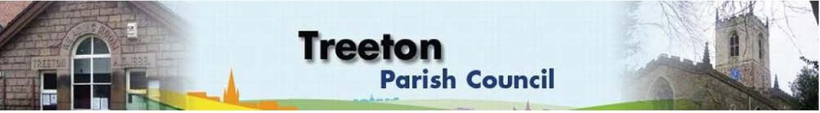

**Clerk to the Council – Mrs J James, 14 Wharncliffe Close, Hoyland, BARNSLEY S74 0HP. Telephone 01226 745910 Email:** [**treetonpc@aol.com**](mailto:treetonpc@aol.com)

**Website:** [**www.treetonparishcouncil.gov.uk**](http://www.treetonparishcouncil.gov.uk/)

1. Apologies and to resolve to accept any reasons for absence.
2. Public Question Time (Maximum 15 minutes.).
3. Declaration of Interest (Councillors must declare any interest they have in agenda items)
4. Approve minutes of the meeting held on 26th July 2021 (attached)
5. Matters arising not elsewhere on the agenda.
6. Co-option of interested parties to fill 1 vacant Parish Council seat
7. Clerk’s report & correspondence
8. Borough Councillors Report
9. Proposal for secure Parish Council emails – Cllr O Dixon
10. Proposal for the Parish Council web presence – Cllr O Dixon
11. Planning & Review of progress on projects through 2021 (attached)
    1. Decision on Christmas lights/trees – L Pickford
    2. Proposals from meeting with RMBC regarding improvements to Well Lane play park - Cllr E Levin
    3. Update on proposals for the Cowfield – Cllr E. Levin
12. Standing items

EXCLUSION OF THE PUBLIC

To consider exclusion of the Press & Public on the grounds that the consideration of the following items may involve the likely disclosure of confidential information (s1 (2) Public Bodies (Admission of Meetings) Act 1960).

Update on actions in respect of Staffing Resources to deliver Parish Priorities Any other urgent business Date of next meeting – Monday 25th October 2021 Adoption of revised Complaints Policy (attached) Approval of Risk Assessment (attached) Staffing – Decision on Village Handyperson Vacancy (to follow) Budget Monitoring (attached) Approval of accounts for payment (to follow) Community Centre - Cllr Adair Chairman's Review. Finance & General Purposes. RMBC/Parish Council’s Liaison Committee - Cllr Adair YLCA Branch Representatives – Cllr Adair Treeton Youth Club - Cllr Adair Community Centre & Playing Fields Memorial Committee - Cllrs Adair/Pickford Report from Representatives on external bodies Reading Room – Revised Letting Agreement (attached) Allotments/Garages Burial Ground – Grounds Maintenance Contract. Report back on progress to repair the path and on registering the land for a potential extension. Recreation Ground and Play areas Environment Planning Applications