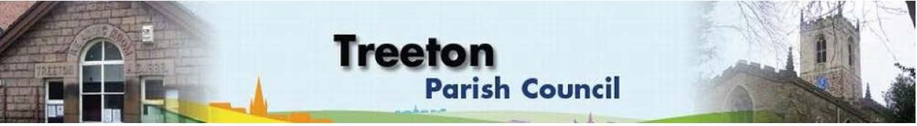

**Clerk to the Council – Mrs J James, 14 Wharncliffe Close, Hoyland, BARNSLEY S74 0HP. Telephone 01226 745910 Email:** [**treetonpc@aol.com**](mailto:treetonpc@aol.com)

**Website:** [**www.treetonparishcouncil.gov.uk**](http://www.treetonparishcouncil.gov.uk/)

14th October 2021

To: The Chairman and Members of the Treeton Parish Council.

Dear Parish Councillors,

You are requested to attend the next Parish Council Meeting commencing at **6.30pm on Monday 25th October 2021** and to be held in the Reading Room.

Below the agenda for the meeting and attached relevant papers.

A list of accounts for payment will be emailed with the Clerks report and updated verbally at the Parish Council meeting as necessary.

Hard copies of papers will be provided for the meeting.

Yours sincerely

1. ***James****.*

Clerk to the Council.

**MEETING OF THE PARISH COUNCIL**

**AGENDA**

1. Apologies and to resolve to accept any reasons for absence.
2. Public Question Time (Maximum 15 minutes.).
3. Declaration of Interest (Councillors must declare any interest they have in agenda items)
4. Approve minutes of the meeting held on 27th September 2021 (attached)
5. Matters arising not elsewhere on the agenda.
6. RMBC Joint Working Agreement – update - Cllr Allen & RMBC Officer
7. Clerk’s report & correspondence
8. Borough Councillors Report
9. Use of secure email addresses – Resolution required - Cllr Dixon
10. Planning & Review of progress on projects through 2021 (attached)
    1. Locations for Christmas tree lights on lampposts
    2. Decision on Flower holsters for 2022
    3. Update on nativity scene – Cllr Beckett
    4. Update on proposals for Well Lane – Cllr Levin
    5. Proposal for MUGA on Cowfield – Cllr Pickford
11. Standing items
12. Reading Room
13. Allotments/Garages:
14. Update on recent allotment check
15. Review of policy with regard to trees
16. Burial Ground – Resolution on contracting grounds maintenance
17. Recreation Ground and Play areas
18. Environment
19. Planning Applications
20. Report from Representatives on external bodies
21. RMBC/Parish Council’s Liaison Committee - Cllr Adair
22. YLCA Branch Representatives – Cllr Adair
23. Treeton Youth Club - Cllr Adair
24. Community Centre & Playing Fields Memorial Committee - Cllrs Adair/Pickford
25. Community Centre - Cllr Adair
26. Chairman's Review.
27. Finance & General Purposes.
28. Review of Policies & Procedures:

* ICO Publication Scheme - unchanged
* Privacy & Data Protection Policy (General & Postholders)- unchanged
* Equality & Diversity- unchanged
* Disciplinary Policy – updated (attached)
* Grievance Policy – updated (attached)
* Performance Appraisal policy – consider adopting (attached)

1. Budget Monitoring (attached)
2. Approval of accounts for payment (to follow)
3. Any other urgent business
4. Date of next meeting – Monday 22nd November 2021

EXCLUSION OF THE PUBLIC

To consider exclusion of the Press & Public on the grounds that the consideration of the following items may involve the likely disclosure of confidential information (s1 (2) Public Bodies (Admission of Meetings) Act 1960).

1. Update on actions - Staffing Resources to deliver Parish Priorities (to follow)
2. Update on property matters (to follow)

C:\Work\Julie\Minutes & agenda\Oct 25 2021\Request to attend and Agenda 25 Oct 21.docx