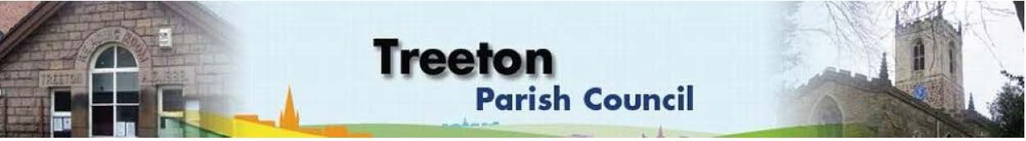

**Clerk to the Council – Mrs J James, 14 Wharncliffe Close, Hoyland, BARNSLEY S74 0HP. Telephone 01226 745910 Email:** [**treetonpc@aol.com**](mailto:treetonpc@aol.com)

**Website:** [**www.treetonparishcouncil.gov.uk**](http://www.treetonparishcouncil.gov.uk/)

11th May 2021

To: The Chairman and Members of the Treeton Parish Council.

Dear Parish Councillors,

You are requested to attend the Annual Meeting of the Parish Council and following Parish Council Meeting commencing at **6.30pm on Monday 17th May 2021** and to be held in the Reading Room.

As this will be our first ‘in person’ meeting for some months’ I would like to respectfully remind you of the COVID guidance with regards to hands, space & face and the regulations and risk assessment for use of the Reading Room which require the wearing of masks.

Below the agenda for the meeting and attached relevant papers.

A list of accounts for payment will be emailed with the Clerks report and updated verbally at the Parish Council meeting as necessary.

Hard copies of papers will be provided for the meeting.

Yours sincerely

1. ***James****.*

Clerk to the Council.

**ANNUAL MEETING OF THE PARISH COUNCIL**

**AGENDA**

1. Declaration of Acceptance of Office
2. Completion of Register of Interest
3. Election of Chairman.
4. Election of Vice-Chairman
5. Nomination for representative of the Parish Council on the following external bodies:
6. RMBC Parish Liaison Committee
7. YLCA Branch
8. Community Centre & Playing Fields Memorial Committee

**MEETING OF THE PARISH COUNCIL**

**AGENDA**

1. Apologies and to resolve to accept any reasons for absence.
2. Public Question Time (Maximum 15 minutes.).
3. Declaration of Interest (Councillors must declare any interest they have in agenda items)
4. Approve minutes of the meeting held on 26th April 2021 (attached)
5. Matters arising not elsewhere on the agenda.
6. Clerk’s report & correspondence
7. Borough Councillors Report
8. Co-option of interested parties to fill 3 vacant Parish Council seats
9. Allotment land rear of Mill Lane – Decision on any interest you wish to hold. (attached)
10. Planning & Review of progress on projects through 2021 (attached)
11. Annual Review of:
    1. Standing Orders (attached)
    2. Financial Regulations (attached)
    3. Financial Risk Assessment & Internal Controls (attached)
12. Standing items:
13. Reading Room
14. Allotments
15. Burial Ground
16. Recreation Ground and Play areas
17. Environment:
18. Planning Applications
19. Report from Representatives on external bodies:
    1. RMBC/Parish Council’s Liaison Committee (T Adair)
    2. YLCA Branch Representatives (T Adair)
    3. Treeton Youth Club (T Adair)
    4. Community Centre & Playing Fields Memorial Committee (T Adair)
20. Community Centre
21. Chairman's Review.
22. Finance & General Purposes.
    1. Budget Monitoring (attached)
    2. Signatories to the bank account
    3. Approval of accounts for payment (to follow)
23. Any other urgent business
24. Date of next meeting – Monday 28th June 2021

C:\Work\Julie\Minutes & agenda\May 17 2021 Ann Mtg of PC\Request to attend & agenda May Ann Mtg PC & Parish Ccl Mtg 17 May 2021.docx