TREETON

PARISH COUNCIL

Emergency Plan

Plan Distribution List

Holder Name | Role | Phone number / email address
Julie James | Clerk to the Council | 07868 813 547  treetonpc@aol.com
In folder on the wall inside the main hall of the Reading Room

Wendy Parker-Foers | Chairperson | 07973 310 680. wendyfoers@googlemail.com
Olly Baum-Dixon | Vice Chairperson | 07939 282 632  ollybaumdixon@gmail.com
Terry Adair | Parish Councillor | 07886 520 586 &  0114 269 5418 mr_tadair@yahoo.co.uk
Victoria Beckett | Parish Councillor | Tel: 0793 2719 877  v.beckett75@outlook.com
Jenny Chadburn | Parish Councillor | 07412 173 299 jennychadburn0712@gmail.com
Bob Croxton | Parish Councillor | 07740 589 805  bobcroxton20@gmail.com
Kevin Hickey | Parish Councillor | 07764 961 367 kevin@powercommand.co.uk
Rachel Rowbottom | Parish Councillor | 07914 862 538  rrtreetonpc@gmail.com
RMBC Parish Council Liaison Officer on behalf of the Emergency Planning Team |  | 01709 247697  07425 616 516  catherine.oxtoby@rotherham.gov.uk

This document contains personal contact details and must not be distributed any further than those named above.

Plan Amendment List

Date of Amendment | Date for Next Revision | Details of Changes Made | Changed by:
September 2020 | May 21 (Elections) | Update all contact details | Julie James
October 2021 | September 2022 | Update all contact details & for V2 RMBC template | Julie James
September 2022 | September 2023 | Update all contact details, update contents | Julie James
February 2023 | September 2023 | Update all contact details | Julie James
September 2023 | May 24 (Elections) | Update all contact details | Julie James
May 24 | May 25

Contents

Title | Page no
Plan Distribution List | 2
Plan Amendment List | 3
Introduction & Administration  - Health & Safety  - Plan alterations & queries  - Aim  - Definition of a major incident  - Emergency  - Role of Emergency Services and Local Authorities  - What is meant by an emergency or incident?  - Types of potential emergency which might affect Treeton | 5
Risk Appreciation  - Community  - Social  - Environmental  - Infrastructure  - Communications  - Utilities  - Vulnerable Treeton residents – support from Utility companies  es | 8
Checklist for actions in the event of a major emergency involving the emergency services and RMBC Emergency Planning Team | 11
Plan Activation | 12
Activation of RMBC Emergency Plan | 13
Control & Co-ordination structure of RMBC’s response to a major incident | 14
Implementing Treeton Parish Council’s Emergency Plan | 16
Roles & Responsibilities  - RMBC  - Treeton Parish Council  - Parish Councillors | 17
Response Options & Resources  - Local area map with resources | 18
Community Liaison & Assistance with emergency resources | 20
Local Contact Information | 21
Borough wide and National contacts and resources | 22
Log Sheet | 24

Introduction and Administration

Health and Safety

Regardless of a major incident all provisions under Health and Safety Legislation

continue to apply. The requirement to respond to an emergency situation does not

override the Parish/Ward Council’s or individual duties to themselves or others under

the Health & Safety Legislation. Where safety advice is provided by the Emergency

Services, Rotherham Metropolitan Borough Council (RMBC) or other emergency

responders this advice must be followed.

If in any doubt all employees and volunteers should always STOP and seek competent

advice from the lead emergency responders at the scene.

Plan Issue, Amendment and Queries

Amendments to this plan can only be issued by the Clerk to the Council. Telephone

numbers are to be checked at three monthly intervals. Any queries concerning this plan

or suggested amendments or corrections should be submitted to:

Treeton Parish Council

Telephone No: 07868 813 547

E-mail address: Treetonpc@aol.com

Aim

This plan identifies how Treeton Parish Council will respond to a community emergency or a declared major incident and is in line with guidance received from the Emergency and Safety Team, Rotherham Metropolitan Borough Council (RMBC).

In the event of an emergency or major incident occurring within or near to the border of Parish/Town Council, the principal concerns of the Parish Council will be to assist RMBC in helping to:

• Support the Emergency Services in preserving life and property

• Support and care for the Community

• Mitigate the effects of the incident

• Restoration of the Community and Environment

Definition of a Major Incident

For the purposes of this plan, a Major Incident’ is defined by the Cabinet Office as ‘An event or situation, with a range of serious consequences, which requires special arrangements to be implemented by one or more emergency responder agencies.

Emergency

A smaller scale incident may also have an impact on the community but not meet the definition of major incident criteria. The Parish Council may wish to consider the provision of assistance to the local community in emergencies of lesser impacts, examples could include the provision of community reassurance, assistance with drop off points for bottled water, sand bags etc.

Role of Emergency Services and Local Authorities

Major emergencies are normally dealt with in a co-ordinated joint response by the emergency services, local authorities, and the major utilities providers which includes water, power and train operators who are all classed as Category 2 Responders.

The emergency services’ two key objectives are to save and protect life and to contain the emergency.

Local authorities will arrive at the scene behind the emergency services to assume responsibility for the welfare of those individuals who require assistance other than those in the care of the medical services. They will co-ordinate the provision of the voluntary services and arrange accommodation and welfare for those who need it once they have assessed the situation.

What is meant by an emergency or incident?

An emergency or incident is an event or situation which threatens serious damage to humans only if it involves, causes or may cause:

- Loss of human life
- Human illness or injury
- Homelessness
- Damage to property
- Disruption to the supply of money, food, electricity or water
- Disruption to communication systems such as telephones and internet for more than 12 hours
- Disruption to transport
- Disruption of services related to health

Or an event or situation which involves serious damage to the environment only if it involves, causes or may cause:

- Contamination of land, water or air with biological or chemical matter or disruption or destruction of animal or plant life

And also, war or terrorism
.

Types of potential emergency which might affect Treeton
- Flu or infections disease pandemic
- Major transport incident, especially damage to Mill Lane railway bridge.
- Adverse weather/storm damage
- Parish at risk of being cut off due to flooding at Mill Lane and an additional incident at either Treeton Lane to Aughton or Long Lane.
- Total loss of electricity and water services
- Explosion/Major fire/Gas leak or plume
- Building collapse

Risk Appreciation

South Yorkshire Community Risk Register

A risk appreciation identifies some of the most likely risks to Treeton and therefore enables the Parish Council to identify some of the possible response mechanisms.

A South Yorkshire wide Community Risk Register (CRR) has been prepared by the SY Local Resilience Forum for the whole of South Yorkshire (SY). Although these risks are not specific to Treeton. The CRR has been referred to as part of the following risk appreciation. The SY CRR can be viewed here:

https://www.southyorks.police.uk/find-out/south-yorkshire-local-resilience-forum/

Community risks

Community risks can be broadly placed into five groups: social, environmental, infrastructure, communications and utilities.

Social

The population of our community generally consists of mixed in terms of age & socio demographics i.e. a mix of elderly, young families, commuter population, within a village/semi-rural setting.

In the event of a major incident the most likely areas of vulnerable persons would be
- Warden supported, semi-independent tenanted social housing
- Residential care home
- Community centre
- Some elderly persons bungalows
- Primary school
- Day nursery
- Some isolated properties

Environmental

Treeton is in an EA flood risk area https://www.gov.uk/check-flood-risk

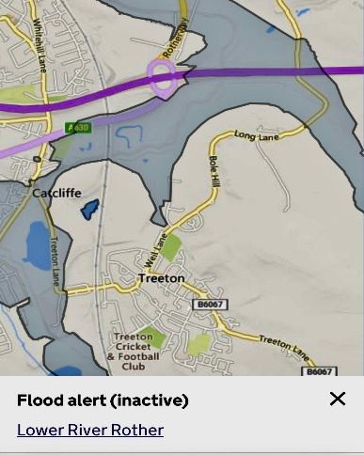

There is a particular risk from flooding by the river Rother which may cut off two of three access roads into/from Treeton:

- Treeton Lane from Catcliffe
- Long Lane out to Whiston.

The river may encroach into houses on Mill Lane and onto farm land and farm houses on Flatts Lane.

Should both the above flood this will leave just Treeton Lane to Aughton as the only remaining access road into/from Treeton.

Treeton Lane to Aughton has a history of flooding from surface water from nearby farmland and thus RMBC have been requested to undertake drainage works to reduce this risk. At the time of writing these works are in progress.

There is some risk of isolation in the event of heavy snow due to the topography of the 3 access roads however they are on RMBC’s priority gritting route.

Infrastructure

There are 3 access roads in/out of Treeton two of which are narrow lanes with bends beyond the village boundary and the third B6067 Mill Lane crosses over a single carriageway traffic light-controlled railway bridge.

Whilst protected with walls either side of the road and a footpath on one side any impact to the walls by traffic could block this access route potentially for a considerable amount of time.

Bridge strikes should be reported by telephone to 01904 718074 quoting Bridge Reference CHR/131

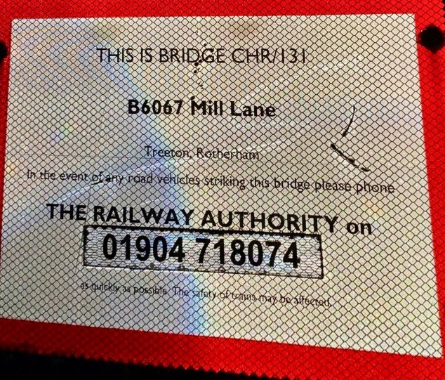

Communications

Any emergency could lead to a disruption of communications: landline and mobile phones, social media, television and radio etc.

The Parish Council will liaise directly with Rotherham Borough Council and will be a conduit into support from village groups and businesses e.g. Community Centre, Churches, Post Office, Miners Welfare, Cricket Club etc.

The Parish Council will communicate by the most appropriate and timely method via formal and informal communication with details of who to contact. Residents and village organisations will also be made aware of any incident

Communication during disruption would be via word-of-mouth cascade using key local businesses and community groups and onwards via family and neighbours to vulnerable persons.

Utilities

Any emergency could lead to a disruption of utility provision in terms of water, gas or electricity.

Vulnerable Treeton Residents – Support from Utility Companies

Many residents and people who run groups and activities in the village will know of people who they might think of as vulnerable due to infirmity, age or other reason (for instance families with young children can be thought of as vulnerable). There is no formal list at present although Social Services has a list of its own clients, which can be activated in an emergency situation.

It is possible to register via the Priority Services Register here for both gas & electricity:
https://www.thepsr.co.uk/#:~:text=The%20Priority%20Services%20Register%20(PSR)%20is%20free%20to%20join.,communication%2C%20access%20or%20safety%20needs.

You can also register for electricity services at Northern Power Grid Yorkshire here:

https://www.northernpowergrid.com/care?utm_source=thepsr&utm_medium=web

Gas services are provided by Cadent and registration is via the Priority Services Register.

For water services this is provided by Yorkshire Water, register here:
https://www.yorkshirewater.com/bill-account/priority-services-register/

When registrations have been processed, extra support is then offered if vulnerable residents are ever without gas, water, or electricity supply.

Checklist for actions in the event of a major emergency involving the emergency services and RMBC Emergency Planning Team

- Contact emergency services  - Call 999  - Give them the following information:  - Your name  - Your contact numbers  - Exact location  - Details of the Incident  - Hazards& road blockages  - Access  - Estimated casualties  - Emergency  Services requested | 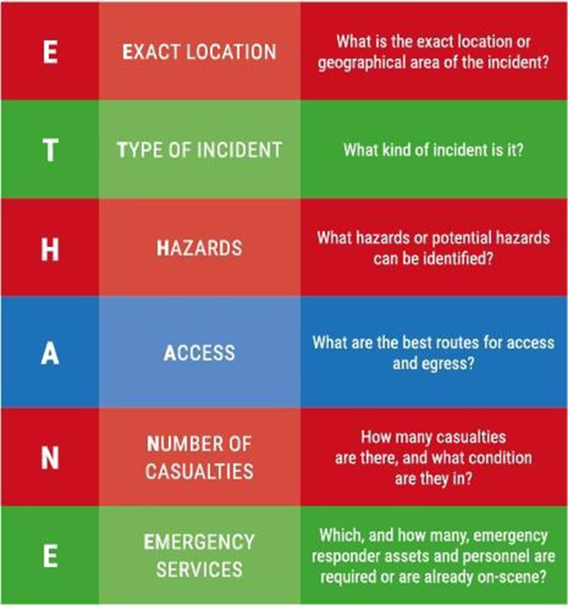
- Contact RMBC Emergency Planning Officer
- Contact the Clerk and Chairman of the Parish Council
- Contact / alert emergency reception space key holders
- Contact utilities

The commencement of an Emergency Plan procedure will be at the discretion of the RMBC Emergency Planning Team who will decide whether to initiate contacting volunteers, and if so, which ones, and will take advice from the Emergency Services

Plan Activation

Notification

Treeton Parish Council would be notified either through:

• Direct from RMBC Emergency Operations Room
• Direct from Chief Executives Directorate Control Room
• Council Scrutiny Team

Command and Control

The following diagrams set out the activation of RMBC response, which includes
the response of Treeton Parish (Parish Council notification procedures have been provided to RMBC EPSS).

Nothing in this plan over-rides the discretion of Treeton Parish Councillors as private individuals to be involved in the response to an incident to take such action as they feel fit in the circumstances prevailing at the time, providing always that such action and the reason(s) for it shall be properly recorded at the time.

activation of THE rmbc mAJOR iNCIDENT PLAN
Incident

A Major Incident could arise in two ways:

(1) (2)
Parish/ Town Council(s) notified
Officers notified to staff Directorate Control Room
Officers notified to staff Borough Emergency Operations Room
Remainder of Strategic Leadership Team notified and Borough Emergency Plan initiated
Duty Forward Liaison Officer deployed to incident site
Duty Borough Emergency Co-ordinator alerted
Directorate(s) require(s) corporate assistance
Duty Forward Liaison Officer alerted
An Incident develops into an emergency over a period of time
Emergency Services respond to an Incident
Scrutiny alerted
Leader of the Council
Chief Executive
Appropriate Ward Member alerted
Forward Liaison Officer alerted
Emergency and Safety Team alerted
Co-ordination Structure of RMBC Response to a Major Incident
Council Leader
Chief Executive

Strategic Representative at Strategic Coordinating Group (SCG)

Borough Emergency Coordinator

Borough Emergency Operations Room (BEOR)

Forward Liaison Officer

Finance and Customer Services

ACHPH Control Arrangements

Assistant Chief Executive

R&E Control Arrangements

CYPS Control Arrangements

- The BEOR controls and co-ordinates the whole corporate council response.

- Directorate Control Rooms instigate the deployment of the many resources or opening up of facilities.

Implementing the Treeton Parish Council Plan

Once the decision has been made to activate the Treeton Parish Council emergency plan the Parish Council will hold an emergency meeting to discuss and confirm response actions. The following draft initial agenda will be reviewed:

Draft Initial Meeting Agenda

- Situation Brief
- Any flood warnings or weather warnings in place
- Area affected
- What has happened and future concerns
- Updates and advice from RMBC and/or emergency services/other agencies, including safety advice, decision to evacuate and shelter requirements

- Review Roles and Responsibilities

- Vulnerable Persons
- Who could be vulnerable in this emergency?
- Any known risk to life call ‘999’
- What assistance can we provide
- Are RMBC aware of these needs?

- Resources and Response Available
- What has RMBC offered or put into place i.e. Emergency Reception Centres, equipment etc
- Have members of the community already gone to a community space?
- What community buildings do we have available and are they outside of the affected areas i.e. flood risk areas?
- What welfare provisions, food, water, blankets etc are available including from RMBC?
- Availability of generators, snow ploughs etc
- Snow Wardens
- Flood Wardens

- Confirm Actions and Communicate Actions to RMBC

Roles & Responsibilities

RMBC Role and Responsibilities

In a major incident RMBC will consider a wide range of actions, however the implementation of these will depend upon the unique circumstances and situation of the major incident at the time. These roles and responsibilities include:

- Establishment of RMBC major incident command and control structures
- Establishment of the remote or physical Borough Emergency Operations Room as required
- Integration with wider multi-agency partner command and control i.e. Strategic Coordinating Group
- Notifying and communicating with partners including Parish and Ward Councils
- Warning and informing
- Identification of known and unknown vulnerable persons
- Provision of emergency shelter and transportation if appropriate
- Provision of welfare support as appropriate
- Contact Centre
- Road closures and diversions
- Sandbags if appropriate and reasonably practical
- Support to the emergency services and other responding partners as appropriate and reasonably practical
- Support to Parish and Ward Councils as appropriate and reasonably practical

Roles and Responsibilities of Treeton Parish Council

As a general principal, the major incident responsibilities of Treeton Parish Council will be an extension of an amplification of the normal responsibilities, however, the essence of good major incident response arrangements is flexibility. Treeton Parish Council will have discretion to re-assign roles and responsibilities throughout the response as considered appropriate and in support of statutory bodies.

Parish Councillors Roles and Responsibilities

In the event of a major incident, input from Treeton as an affected locality will be crucial to Rotherham MBC’s overall response. Treeton Parish Councillors, as representatives of the community, will help provide Ward Members with a clear understanding of the concerns and needs of the people in the affected area. Equally Treeton Parish Councillors will be able to reflect to local people the work being undertaken by RMBC and other emergency responders and the reasons for any decisions which are taken or which may be made.

Response Options and Resources

Treeton Parish Council has identified the following possible response & shelter options:

Centre Location and Capacity | Facilities | Main normal contact & keyholders
Treeton Parish Council  Reading Room  25 Front Street  Treeton  Capacity: 80 (40 if seated) | Large open space  Chairs and tables  Basic kitchen facilities  Toilets incl disabled & baby changing  Defibrillator on outside wall - accessible 24 hrs | Parish Councillors  Contact details on page 2 & on the notice board outside the Reading Room and on the web here:  https://www.treetonparishcouncil.gov.uk/homepage/3/parish-councillors  Staff Team  Key box with access code known to the above.
Community Centre  Pit Lane  Treeton  Capacity: 150 | Meeting room and several large open spaces, office space.  Enclosed garden space.  Kitchen facilities  Toilets incl disabled & baby changing  Defibrillator on outside wall – accessible 24 hrs | Terry Adair  0788 652 0586
Miners Welfare  Arundel Street  Treeton  Capacity 150 | Pub facilities  Function room  Toilets. | Julie Levin  07775 610 575
Cricket Club  Washfield Lane  Treeton  Capacity 100 | Bar and function room  Toilets. | Nick Kendall  07771 631 892
Treeton Primary School  Capacity: 300 | School hall  Classrooms  Chairs and tables  Kitchen  Toilets | School Office  0114 269 2677
Treeton Baptist Church  Capacity: 158 Seated | School room  Church space  Chairs, tables, pews  Kitchen  Toilets | Ida Levin  07986 224 245 &  0114 269 0242  Beryl (Belle) Nuttall  07847 067 818 &  01709 376 859

Local area map and community resources

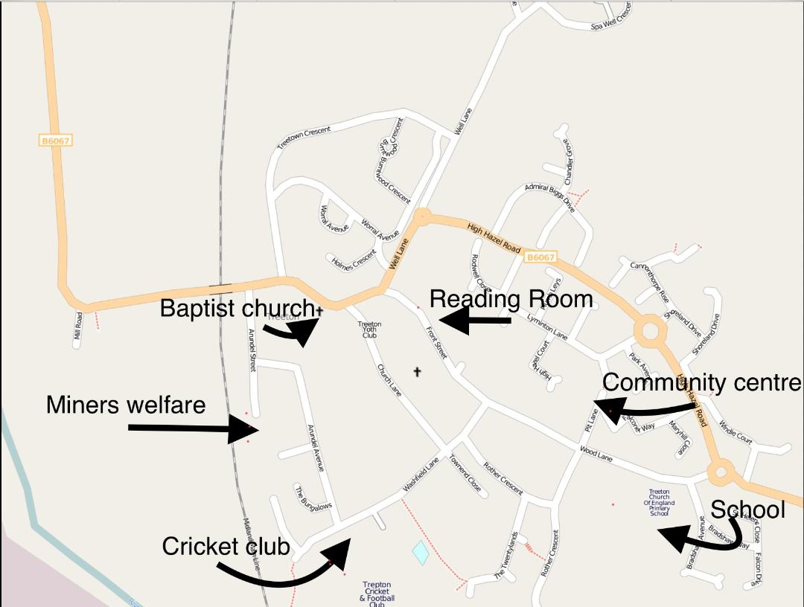

Community Shelters

Community shelters may be used where people need to evacuate or seek welfare assistance in terms of hot drinks etc locally to their community. Prior to establishing a community shelter it is the responsibility of Treeton Parish Council to ensure:

- Communication with RMBC to confirm the safety advice of an evacuation. There are circumstances where the emergency services may advise remaining indoors, with windows and doors closed, this advice MUST be followed where given
- A parish community shelter may be established and used to provide immediate shelter for the community. Liaison with RMBC must take place as a decision may be taken to establish a larger emergency reception centre elsewhere within the Borough and/or to support the parish community shelter, depending on the circumstances of the incident.
- Community shelters must have the resources to accommodate vulnerable and disabled persons i.e. wheelchair accessible
- People will often NOT evacuate and leave pets behind, provision to accommodate pets on leads or in carriers should also be made, especially where the decision is being made by RMBC to support the community shelter

Treeton Parish Council can confirm that no shelters are located in a flood risk area or would be cut off during a flood

Community Liaison

Treeton Parish Council’s usual methods of community liaison are via:

- Social media
- Website
- Notice Board
- Community meetings

In the event of an emergency or power failure where resources permit the Parish Council may also consider door knocking.

Assistance with Emergency Distributions

In some emergencies the emergency responders may be in a position to provide resources and welfare assistance for example the distribution of water bottles, sandbags, portable heaters, food etc. In these events the emergency responders may require the assistance of the Treeton Parish Council to identify locations in the community which are:

- Accessible by HGV access
- Easy to get to by the public
- Parking
- Assistance with communicating to the community
- Assistance with the identification of vulnerable persons and delivery of these items to vulnerable persons who may not be able to collect items available for distribution
- Preferably these locations should be outside of a flood risk area

Potential Community Emergency Distribution Points

Address | HGV access | Disability access | Public car parking | Located in a flood area?
Reading Room | Y | Y | Roadside | N
Community Centre | Y | Y | Roadside | N
Miners Welfare | Y | Y | Y | N
Cricket Club | Y | Y | Y | N
Baptist Church | Y | Y | Roadside | N

Local Information

Local Organisations and Businesses
Subject / resource | Name | Address | Landline / Mobile
Parish Council | Julie James  Parish Clerk |  | 01226 745910  07868 813 547
Community Centre | Terry Adair | Pit Lane | 07886 520 586
Miners Welfare | Julie Levin | Arundel Street | 07775 610 575
Cricket Club | Nick Kendall | Washfield Lane | 07771 631 892
Treeton Primary School | Mrs. E Minhas Headteacher | Wood Lane | 0114 269 2677
Baptist Church | Ida Levin  Beryl (Belle) Nuttall | Station Road
Treeton Medical Practice |  | Arundel Street | 01142 692 600  https://treeton.gpsurgery.net/
Cohens Chemist |  | Station Road | 01142 939 039  https://www.cohenschemist.co.uk/
Treeton News | Rachel Rowbottom | Front Street | 0114 269 8803  07914 862 2538
Nicols shop |  | Station Road | 07428 161565

Borough-wide & national contacts

Service | Contact Details
RMBC Contacts

Emergency Planning Shared Service | 01709 982 3878
Duty Emergency Planning Officer via switchboard | 01709 382121  01709 336009 (out of hrs)
Children and Young People's Social Services | Telephone: 01709 336080
Adult Social Services | 01709 822330
Rothercare | 01709 371897
Highways & Streetpride including sand bags | 01709 336003
Request Sandbags on line | https://www.rotherham.gov.uk/xfp/form/374
Emergency Housing Repairs | 01709 336009
Media | corporate.comms@rotherham.gov.uk  01709 212300
How to become a snow warden | https://www.rotherham.gov.uk/xfp/form/290
Utilities

Gas leaks | 0800 111 999
Power cuts | 105
Review of planned and unplanned power cuts in your area | https://cms.npproductionadmin.net/power-cuts
Water leaks - Yorkshire Water | 03451 242424

Public Health and Community Safety

Childline | 0800 1111
NSPCC | 0808 800 5000
Domestic abuse and violence helpline | 0808 2000 247
Environment Agency: Flood line | 0345 988 1188
River Levels on the Internet | https://flood-warning-information.service.gov.uk/river-and-sea-levels
Am I at flood risk? For all types of flooding | https://flood-warning-information.service.gov.uk/long-term-flood-risk
Sign up for Environment Agency Flood Warning Service | https://www.fws.environment-agency.gov.uk/app/olr/register
How to become a flood warden | Tel: 02030 356 869  Email:  yorkshirefloodresilience@environment-agency.gov.uk
Met Office: Weather Call | 0370 900 0100  https://www.metoffice.gov.uk/
St John Ambulance | www.sja.org.uk
RSPCA - The RSPCA has put together some guidelines so that you can be prepared to get your animals to safety in the event of flooding. | https://www.rspca.org.uk/adviceandwelfare/seasonal/floods

Log Sheet

Log sheet for Treeton Parish Council’s Emergency Response Plan Activation

Date:
Incident:

Time | Information | Action | Initials

This log sheet is for actions taken by Treeton Parish Council Emergency Response Team.

C:\Work\Julie\Policies Procedures\Emergency Plan Reviewed Feb 24 redacted for web.docx

