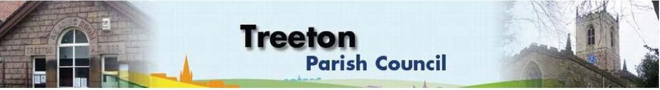
Clerk to the Council – Mrs J James, 14 Wharncliffe Close, Hoyland, BARNSLEY S74 0HP. Telephone 01226 745910 Email: treetonpc@aol.com
Website: www.treetonparishcouncil.gov.uk

14th July 2022

To: The Chairman and Members of the Treeton Parish Council.

Dear Parish Councillors,
You are requested to attend the next Parish Council Meeting at 6.30pm on Monday 25th July 2022 and to be held in the Reading Room.
Below the agenda for the meeting and attached relevant papers.

A list of accounts for payment will be emailed with the Clerks report and updated verbally at the Parish Council meeting as necessary.

Yours sincerely
- James.
Clerk to the Council.

MEETING OF THE PARISH COUNCIL 25th JULY 2022

AGENDA

- Apologies and to resolve to accept any reasons for absence.
- Public Question Time (Maximum 15 minutes.).
- Declaration of Interest (Councillors must declare any interest they have in agenda items)
- Approve minutes of the meeting held on 27th June 2022 (attached)
- Matters arising not elsewhere on the agenda.
- Co-option to 2 vacancies on the Parish Council (expressions of interest to follow)
- Clerk’s report & correspondence
- Borough Councillors Report
- War Memorial - Project for restoration – update from Cllr Parker-Foers
- Decision to purchase land to the rear at nil capital cost from RMBC
- Decision to apply for planning consent to remove some trees and prune others
- Locations for Parish Council Notices – Cllr Croxton
- Planning & Review of progress on projects through 2022 (attached)
- Plans for sport/recreation and other facilities that might be funded through CIL/Reserves:
- Update on discussions with RMBC re Well Lane – Cllr Adair
- Update on proposals to address drainage on the Cowfield – Cllr Adair
- Standing items:
- Reading Room
- Parish Councillor, Housing & PCSO Surgeries
- Proposals for refurbishment – update from Cllrs Beckett & Parker-Foers
- Allotments
- Update from Clerk
- Review of allotment and garage plot rents
- Burial Ground
- Land for Extension – update from Clerk
- Proposals for Burial Ground Guidelines - Cllr Parker-Foers
- Schedule of repair & maintenance - update from Cllr Parker-Foers
- Recreation Ground and Play areas
- Environment
- Planning Applications – to receive and comment
- Report from Representatives on external bodies:
  - RMBC/Parish Council’s Liaison Committee - Cllrs Adair/Baum-Dixon
  - YLCA Branch Representatives - Cllr Adair
  - Banks Group – Penny Hill Wind Farm – Cllr Adair
  - Treeton Youth Club – Cllr Adair
  - Community Centre & Playing Fields Memorial Cttee Cllrs Adair/Baum-Dixon
- Community Centre Update– Cllr Adair
- Chairman's Review.
- Finance & General Purposes.
  - Internal Control, Reconciliation & Accountability (to follow)
  - Budget Monitoring (attached)
  - Approval of accounts for payment (to follow)
- Any other urgent business
- Date of next meeting – Monday 26th September 2022

EXCLUSION OF THE PUBLIC

To consider exclusion of the Press & Public on the grounds that the consideration of the following items may involve the likely disclosure of confidential information (s1 (2) Public Bodies (Admission of Meetings) Act 1960).

- Allotment – condition issues.
- Staffing Resources – review of capacity (to follow)

C:\Work\Julie\Minutes & agenda\July 21 2022\Request to attend & agenda 25 July 22 PC meeting.docx

