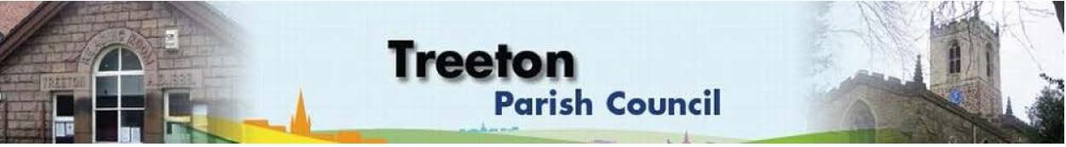
Clerk to the Council – Mrs J James, 14 Wharncliffe Close, Hoyland, BARNSLEY S74 0HP. Telephone 01226 745910 Email: treetonpc@aol.com
Website: www.treetonparishcouncil.gov.uk

18th May 2022

To: The Chairman and Members of the Treeton Parish Council.

Dear Parish Councillors,
You are requested to attend the Annual Meeting of the Parish Council and following Parish Council Meeting commencing immediately following the Annual Meeting of the Parish which is at 6.30pm on Monday 30th May 2022 and to be held in the Reading Room.
Below the agenda for the meeting and attached relevant papers.

A list of accounts for payment will be emailed with the Clerks report and updated verbally at the Parish Council meeting as necessary.

Yours sincerely
- James.
Clerk to the Council.

ANNUAL MEETING OF THE PARISH COUNCIL 30th MAY 2022

AGENDA

- Election of Chairman.
- Election of Vice-Chairman
- Nomination for representative of the Parish Council on the following external bodies:
- RMBC Parish Liaison Committee
- YLCA Branch
- Banks Group
- Treeton Parish Council Youth Club
- Community Centre & Playing Fields Memorial Committee

MEETING OF THE PARISH COUNCIL 30th MAY 2022

AGENDA

- Apologies and to resolve to accept any reasons for absence.
- Public Question Time (Maximum 15 minutes.).
- Declaration of Interest (Councillors must declare any interest they have in agenda items)
- Approve minutes of the meeting held on 25th April 2022 (attached)
- Matters arising not elsewhere on the agenda.
- Clerk’s report & correspondence
- Borough Councillors Report
- War Memorial -proposals for restoration – Cllr Parker-Foers
- Use of Secure E-Mail addresses – Cllr Baum-Dixon
- Planning & Review of progress on projects through 2022 (attached)
- Plans for sport/recreation and other facilities that might be funded through CIL/Reserves:
- Update on discussions with RMBC re Well Lane – Cllr Adair
- Update on proposals to address drainage on the Cowfield – Cllr Adair
- Plans for HM The Queen’s Jubilee:
- Final preparations & to agree Risk Assessment for Bake off (attached 4 docs)
- Update on commemorative tree planting & proposal for a bench -Clerk
- Annual Review of Standing Orders, Financial Regulations, Financial Risk Assessment & Internal Controls, Approval for Continuing Payments (attached)
- Standing items:
- Reading Room
- Parish Councillor, Housing & PCSO Surgeries
- Proposals for refurbishment
- Allotments
- Burial Ground
- Land for Extension
- Proposals for Burial Ground Guidelines & a programme of repairs and maintenance. Cllrs Beckett & Parker-Foers
- Recreation Ground and Play areas
- Environment: Planted ‘Treeton’ on Wood Lane – Clerk
- Planning Applications
- Report from Representatives on external bodies:
  - RMBC/Parish Council’s Liaison Committee - Cllr Adair
  - YLCA Branch Representatives - Cllr Adair
  - Banks Group – Penny Hill Wind Farm – Cllr Adair
  - Treeton Youth Club – Cllr Adair
  - Community Centre & Playing Fields Memorial Committee Cllr Adair
- Community Centre – Cllr Adair
- Chairman's Review.
- Finance & General Purposes.
  - Budget Monitoring (attached)
  - Approval of accounts for payment (to follow)
- Any other urgent business
- Date of next meeting – Monday 27th June 2022

C:\Work\Julie\Minutes & agenda\2022\Request to attend & agenda May Ann Mtg PC & Parish Ccl Mtg 30 May 2022.docx

